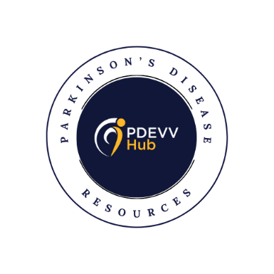
Board Recruitment
Founded in 2022, PDEVV Hub Inc is dedicated to raising support and awareness for Parkinson’s Disease in the Tri-state area, as well as providing resources about Parkinson’s Disease (“PD”). The Board of Director’s is composed of local community leaders and volunteers who speak with individuals and families, present at local businesses, share resources through exhibit tables, and provide resources to local medical offices about all the opportunities to exercise and encourage those living with a Parkinson’s diagnosis in our tri-state area.
You or someone you know might be an eligible candidate if…
- You are active in the community and are drawn to do more
- You are a leader in our community and have non-profit board experience
- You are a person living with Parkinson’s, care partner or wellness professional passionate about our mission to help people with Parkinson’s learn about the resources available in our communities of Evansville, Indiana and Henderson, Kentucky.
Serve as a Board Member
- The Nominating Committee is inviting applications from persons interested in being considered for the role of PDEVV Hub Board Director. There are three (3) Board Director vacancies to be filled, each for a two (2) year term (2025 – 2027).
Time Commitment
- Attend in-person two-hour board meeting four times per year (Jan, Apr, Jul, Oct)
- Time to read and prepare for meetings (one-half hour per meeting)
- Participate in, help with, and attend our two major annual events
o Tulip Trot – a walk/run to raise awareness and funding each spring
o Symposium – a full-day event for patients and caregivers to provide health and lifestyle information to help them on their Parkinson’s journey
Selection Process
- All applicants must submit a letter of interest describing why they are interested in serving & a resume by Jun 27, 2025, to PDEVV Hub at pdevvhub@gmail.com. Please include any relationships to other board members or any other boards that you currently serve. Also, include the skills that you can offer.
- Selected applicants will be contacted to arrange a virtual interview
Questions can be directed to the PDEVV Hub at pdevvhub@gmail.com

